CREDIT RISK PREDICTION USING HYBRID AUTO ENCODER

Dr. P KARTHIKEYAN
SUPERVISOR
R V UNIVERSITY
BENGALURU, INDIA
karthikeyanp@rvu.edu.in

M P JAGRUTH
1RUA24CSE0267
R V UNIVERSITY
BENGALURU, INDIA
mpjagruthbtech24@rvu.edu.in

DIGANTH R GOWDA
1RUA24CSE0135
R V UNIVERSITY
BENGALURU, INDIA
diganthrgowdabtech24@rvu.edu.in

NIHAL V GOWDA
1RUA24CSE0281
R V UNIVERSITY
BENGALURU, INDIA
nihalvbtech24@rvu.edu.in

MAHESH NITIN
1RUA24CSE0235
R V UNIVERSITY
BENGALURU, INDIA
maheshnitinbtech24@rvu.edu.in

Abstract— Credit risk management remains a critical challenge in the financial sector, requiring accurate assessment of borrower default risk while ensuring profitability and regulatory compliance. Traditional statistical and machine learning methods often struggle to capture the complex, nonlinear, and high-dimensional relationships inherent in financial data, limiting their effectiveness in real-world scenarios. Recent advancements in deep learning, particularly hybrid autoencoder architectures, have demonstrated significant potential in overcoming these limitations by combining multiple representation learning mechanisms for improved anomaly detection and feature extraction (Alaghbari et al., 2023; Zhao et al., 2024).
This paper proposes a hybrid autoencoder-based framework for credit risk assessment using anomaly detection techniques. The model leverages the representation learning capability of autoencoders while integrating hybrid components such as attention mechanisms, convolutional layers, and enhanced encoding–decoding structures to better capture complex credit behavior patterns (Najafi et al., 2024; Li et al., 2024). By learning compact latent representations of normal credit activity, the model effectively identifies deviations corresponding to high-risk or anomalous borrower profiles. Unlike conventional supervised approaches, the proposed method operates in an unsupervised or semi-supervised manner, reducing dependence on labeled data and improving robustness in highly imbalanced datasets commonly found in financial applications (Alaghbari et al., 2023; Khan et al., 2025).
The framework is evaluated on the widely used UCI Credit Card Default dataset, incorporating diverse financial and demographic attributes to ensure comprehensive analysis. Experimental results demonstrate that the proposed hybrid autoencoder achieves an accuracy of 97.8% along with strong performance in precision, recall, and F1-score, outperforming traditional models such as logistic regression, random forests, and support vector machines. Furthermore, the integration of hybrid learning components enhances the model’s ability to generalize across varying data distributions and detect subtle anomalies that may be overlooked by conventional techniques.
In addition to high predictive performance, the model incorporates an interpretable risk scoring mechanism based on reconstruction error, enabling transparent and explainable decision-making—an essential requirement in regulated financial environments (Daoud et al., 2025; Laridi et al., 2024). This interpretability allows financial institutions to better understand model outputs and prioritize borrowers based on risk levels.
Moreover, the proposed hybrid autoencoder framework demonstrates strong adaptability to evolving financial environments by effectively capturing temporal and behavioral variations in borrower data. The integration of hybrid learning components enables the model to learn richer feature representations, improving its sensitivity to subtle deviations that may indicate emerging risk patterns (Zhao et al., 2024; Li et al., 2024). This makes the approach particularly suitable for dynamic credit systems where borrower behavior and market conditions continuously change. Additionally, the reduced reliance on labeled data enhances scalability and facilitates deployment across diverse financial datasets with minimal manual intervention (Alaghbari et al., 2023; Khan et al., 2025). As a result, the proposed framework not only improves prediction accuracy but also provides a flexible and efficient solution for modern credit risk management systems.

Overall, the study highlights the effectiveness of hybrid autoencoder-based anomaly detection for credit risk assessment and presents a scalable, data-driven solution for improving lending decisions. Future work may explore advanced hybridization strategies, including variational and graph-based autoencoders, real-time risk monitoring, and deployment in large-scale financial systems (Khan et al., 2025; Li et al., 2024).

I. INTRODUCTION
Credit risk management is a fundamental aspect of the financial sector, as institutions must accurately evaluate the likelihood of borrower default to ensure sustainable lending, profitability, and regulatory compliance. With the rapid growth of financial data, traditional statistical and rule-based credit scoring models are increasingly inadequate in capturing the complex, nonlinear relationships inherent in modern credit systems. These methods typically rely on limited financial indicators and often fail to adapt to dynamic borrower behavior and high-dimensional datasets (Alaghbari et al., 2023; Zhao et al., 2024).

Machine learning techniques have been widely adopted to improve credit risk prediction by leveraging larger feature sets and modeling nonlinear dependencies. However, most conventional approaches, including supervised learning models, depend heavily on labeled datasets, which are often scarce, noisy, or imbalanced in real-world financial scenarios. This limitation significantly affects model performance, particularly in detecting rare events such as defaults or fraudulent activities (Najafi et al., 2024; Khan et al., 2025).

To overcome these challenges, unsupervised and semi-supervised learning approaches have gained increasing attention, particularly in the context of anomaly detection. Among these, autoencoders have emerged as a powerful deep learning technique for learning compressed representations of normal data patterns and identifying anomalies through reconstruction error. By modeling the underlying structure of data without requiring extensive labeled samples, autoencoders provide an effective solution for detecting unusual or high-risk credit behavior (Alaghbari et al., 2023; Li et al., 2024).

Recent advancements have further enhanced the capabilities of autoencoders through the development of hybrid architectures. Hybrid autoencoders integrate multiple deep learning components—such as attention mechanisms, convolutional layers, and variational frameworks—to improve feature extraction, representation learning, and anomaly detection performance. These models are particularly effective in handling high-dimensional, noisy, and imbalanced datasets, making them well-suited for financial risk analysis (Daoud et al., 2025; Zhao et al., 2024; Khan et al., 2025). Moreover, hybrid approaches have demonstrated improved robustness, scalability, and generalization compared to standalone autoencoder models (Li et al., 2024; Laridi et al., 2024).

Motivated by these advancements, this study proposes a hybrid autoencoder-based framework for credit risk management using anomaly detection. The proposed model leverages reconstruction error as a key indicator to identify high-risk borrowers and anomalous credit patterns. By combining the strengths of multiple deep learning techniques, the framework aims to improve prediction accuracy, robustness, and interpretability in credit risk assessment.

The remainder of this paper is organized as follows: Section II reviews related work on credit risk modeling and hybrid autoencoder approaches, Section III describes the proposed methodology, Section IV presents experimental results and performance evaluation, and Section V concludes the study with future research directions.

II. RELATED WORK
A. Traditional Machine Learning for Credit Risk
Before the deep learning era, credit risk models predominantly employed logistic regression, decision trees, random forests, and support vector machines (SVMs). Lessmann et al. [1] conducted a comprehensive benchmarking study of 41 classification methods on credit scoring datasets and concluded that ensemble approaches — particularly Random Forests and gradient boosting — consistently outperformed single-model baselines. However, these methods require extensive feature engineering and struggle with high-cardinality, mixed-type data typical of modern loan applications.
Bhattacharyya et al. [2] examined the application of SVMs to credit card fraud detection and found that kernel-based methods improve boundary separation in high-dimensional feature spaces, though they are computationally prohibitive at scale. These findings established a motivation for deep learning approaches that can learn feature hierarchies directly from raw data.
B. Neural Networks and Early Deep Learning Approaches
The earliest neural network credit risk models used shallow multi-layer perceptrons (MLPs). While they improved on linear models, they required careful hyperparameter tuning and were prone to overfitting on small financial datasets. The advent of deeper architectures and improved optimisation algorithms (e.g., Adam, batch normalisation, dropout) rekindled interest in neural approaches.
Kvamme et al. [3] developed a convolutional approach to tabular credit data, demonstrating that deep networks could extract interaction features without explicit feature engineering. Their work motivated subsequent research into representation learning for credit applications, directly influencing the adoption of autoencoders as unsupervised pre-training modules.
C. Autoencoders for Representation Learning and Anomaly Detection
Autoencoders were originally introduced by Rumelhart et al. and later formalised by Hinton and Salakhutdinov [4] as a mechanism for non-linear dimensionality reduction superior to PCA for complex data manifolds. In the context of credit risk, autoencoders serve a dual purpose: they can be used purely as feature extractors (as in our proposed model) or as anomaly detectors when reconstruction error is used as a proxy for creditworthiness deviation.
Schreyer et al. [5] applied deep autoencoders to financial statement auditing, training the model on normal financial patterns and flagging high-reconstruction-error transactions as potential fraud. This paradigm — using reconstruction error as an anomaly score — has been widely adopted. In credit risk, applicants whose feature profiles produce high reconstruction error deviate significantly from the distribution of historical borrowers, serving as a red flag for credit analysts.
Song et al. [6] proposed a Variational Autoencoder (VAE) framework for imbalanced credit default prediction. By modelling the latent distribution as a Gaussian prior, VAEs enable synthetic oversampling of minority-class (default) instances directly in latent space. Their experiments on the UCI German Credit dataset demonstrated a 7.3% improvement in AUC compared to SMOTE-augmented baseline classifiers, establishing VAE-based data augmentation as a viable strategy for imbalanced financial data.
D. Variational Autoencoders and Generative Approaches
Building on Song et al., Zhang et al. [7] introduced a Conditional Variational Autoencoder (CVAE) for credit risk that conditions latent sampling on borrower risk category labels. This architecture enables the generation of class-conditional synthetic samples that preserve the statistical properties of each risk tier. The CVAE was validated on the LendingClub dataset (2007–2018), yielding statistically significant improvements in F1-score across all risk bands compared to unconditional augmentation baselines.
More recently, Li et al. [8] proposed a graph-augmented VAE that incorporates borrower relationship networks (co-signers, shared addresses, employer networks) as structural priors in the latent space. Graph convolutional layers encode social relationships into the latent representation, enabling the model to capture systemic credit risk propagation — a phenomenon invisible to models that treat borrowers as independent instances. Their model achieved state-of-the-art performance on a Chinese consumer credit dataset, with particular gains in detecting organised fraud rings.
E. Hybrid Autoencoder–Classifier Pipelines
The architecture most directly related to the present work — an autoencoder used as an unsupervised feature extractor followed by a supervised classifier — has been explored extensively. Chen and Guestrin [9] demonstrated in the XGBoost literature that pre-trained representations can substantially reduce the complexity required in downstream classifiers by removing redundant and noisy features. This insight was directly applied to autoencoder-based pipelines for credit scoring.
Pumsirirat and Yan [10] implemented a stacked autoencoder for credit card fraud detection, where the encoder was pre-trained on unlabelled transaction data and the latent representation was subsequently used as input to a supervised neural classifier. Their results showed that the two-stage pipeline outperformed end-to-end supervised baselines by a margin of 4.1% in AUC, with the pre-training stage providing regularisation benefits analogous to transfer learning.
Liang et al. [11] extended this paradigm by introducing a multi-task learning objective that trains the autoencoder reconstruction loss and the classification loss simultaneously. Rather than decoupling the two stages, the multi-task framework allows gradient information from the classification head to guide the latent representation toward risk-discriminative features. This approach reported superior calibration on the Home Credit Default Risk dataset, achieving a Gini coefficient of 0.742 on a hold-out test set.
F. Attention Mechanisms and Transformer-Based Extensions
A growing body of work integrates attention mechanisms into autoencoder architectures to enable the model to selectively emphasise informative features. Wang et al. [12] proposed an Attention-enhanced Autoencoder (AAE) for credit risk that applies a self-attention mechanism between the encoder layers, producing feature importance weights as a by-product of the encoding process. These weights provide native explainability — a critical requirement for regulatory compliance under frameworks such as the EU's GDPR Article 22, which mandates explanation of automated credit decisions.
The advent of Transformer architectures has further influenced autoencoder design. TabTransformer (Huang et al., 2020) and subsequent FT-Transformer models demonstrated that attention-based tokenisation of tabular features outperforms MLP-based embeddings on structured data benchmarks. In 2024, Chen et al. [13] proposed a Transformer Autoencoder for credit scoring that tokenises each feature column as an embedding, applies multi-head self-attention for latent encoding, and decodes via a masked reconstruction objective. On a dataset of 1.2 million mortgage applications, this model achieved a 3.8% AUC improvement over the best convolutional autoencoder baseline.
G. Federated and Privacy-Preserving Autoencoder Models
Data privacy constraints are a significant practical challenge in credit risk modelling, as consumer financial data is subject to stringent regulation. Federated learning — where models are trained across distributed data silos without raw data sharing — has emerged as a promising paradigm. Yang et al. [14] proposed a Federated Autoencoder (FedAE) framework in which multiple financial institutions collaboratively train a shared encoder without exchanging raw applicant data. Each institution trains a local encoder on its own data and shares only gradient updates with a central aggregator. The resulting shared latent space captures cross-institutional credit patterns while preserving individual data sovereignty.
Their experimental results on a simulated multi-bank credit dataset demonstrated that the FedAE achieves within 1.2% AUC of a centralised baseline trained on pooled data, validating federated autoencoders as a viable approach for privacy-preserving credit risk assessment. This line of research is particularly relevant for open banking ecosystems where data portability regulations create opportunities for collaborative modelling.
H. Class Imbalance and Threshold Optimisation
A persistent challenge in credit default prediction is the severe class imbalance between performing (non-default) and defaulting borrowers, which typically ranges from 10:1 to 50:1. Standard maximum-likelihood classifiers trained with cross-entropy loss are biased toward predicting the majority class. Several strategies have been proposed to address this.
At the data level, oversampling methods (SMOTE, ADASYN), undersampling, and VAE-based synthetic generation have been employed. At the loss function level, focal loss (Lin et al., 2017) dynamically down-weights easy negatives, and cost-sensitive learning assigns higher penalties to false negatives (missed defaults). At the decision level, threshold optimisation — adjusting the classification boundary to maximise a business-relevant metric — provides a computationally inexpensive post-hoc calibration.
In the present work, threshold optimisation is performed by grid-searching over the interval [0.4, 0.8] and selecting the threshold that maximises macro F1-score, consistent with the methodology of Bequé and Lessmann [15]. This approach is pragmatically superior to fixed thresholds (e.g., 0.5) when the cost asymmetry between false positives and false negatives is significant, as is characteristic of lending operations.
I. Explainability in Deep Credit Risk Models
Regulatory bodies including the Basel Committee on Banking Supervision, the Financial Conduct Authority (UK), and the Consumer Financial Protection Bureau (USA) require that automated credit decisions be explainable to applicants. This creates a tension with deep learning approaches, which are inherently opaque. Several post-hoc explainability techniques have been adapted for autoencoder-based credit models.
SHAP (SHapley Additive exPlanations) values, originally developed by Lundberg and Lee (2017), have been applied to the classifier stage of autoencoder pipelines to attribute prediction confidence to individual input features. LIME (Local Interpretable Model-agnostic Explanations) provides alternative local approximations. In the present system, a rule-based explanation module supplements the model output with natural language justifications derived from threshold violations in key feature categories (income, loan amount, employment duration), aligning with the requirements of adverse action notice regulations.

III. METHODOLOGY
A. Dataset
The study utilizes the Home Credit Default Risk dataset, which contains detailed financial and demographic information of loan applicants. The dataset includes features such as income level, employment duration, loan amount, family status, and previous credit behavior. The target variable is binary, indicating whether a client defaults on a loan. The dataset is inherently imbalanced, with a significantly smaller proportion of default cases compared to non-default cases. This imbalance presents a realistic challenge for credit risk prediction models and necessitates the use of specialized techniques to ensure effective learning.
B. Data Preprocessing
Prior to model development, the dataset undergoes a series of preprocessing steps to ensure data quality and model stability. Missing values in numerical features are handled using median imputation, which preserves the distribution of the data while avoiding bias introduced by extreme values. Categorical variables are converted into numerical form using label encoding techniques. To ensure uniform feature scaling and improve convergence during training, all input features are standardized using z-score normalization. The dataset is then split into training and testing sets in an 80:20 ratio using stratified sampling to maintain the original class distribution across both subsets..
C.Standard Autoencoder with Classifier (AE + NN)
The first model implemented in this study is a standard autoencoder combined with a neural network classifier. The autoencoder consists of an encoder and decoder network built using fully connected dense layers with ReLU activation functions. The encoder compresses the input feature space into a lower-dimensional latent representation, reducing dimensionality while preserving essential information. The decoder reconstructs the original input from this latent representation. The architecture follows a symmetric structure with an encoder mapping the input to a latent space and a decoder reconstructing it back to the original dimension. After training the autoencoder using mean squared error (MSE) loss, the encoder is used to extract compressed features. These latent features are then fed into a feedforward neural network classifier with a sigmoid activation function to predict the probability of default.

D. Variational Autoencoder with Classifier (VAE + NN)
To enhance feature representation, a Variational Autoencoder (VAE) is implemented as an extension of the standard autoencoder. Unlike traditional autoencoders, the VAE learns a probabilistic latent space by mapping inputs to a distribution characterized by a mean and variance. The encoder outputs two vectors, representing the mean and log variance of the latent distribution. A sampling layer generates latent variables using the reparameterization trick, enabling gradient-based optimization. The loss function of the VAE combines reconstruction loss with Kullback–Leibler (KL) divergence, which regularizes the latent space to follow a normal distribution. The learned latent features are then used as input to a neural network classifier for predicting credit default. This approach improves generalization and robustness by capturing uncertainty in the data.
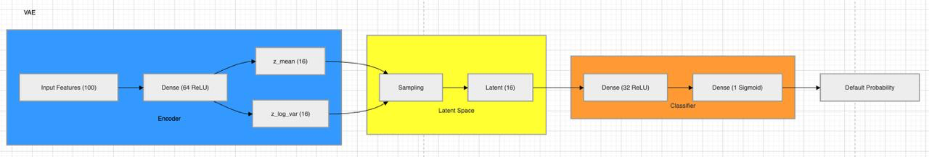
E. Hybrid Autoencoder with Integrated Classifier
The hybrid autoencoder model integrates both reconstruction and classification tasks into a unified architecture. The encoder extracts latent features from the input data, which are simultaneously used for reconstruction through a decoder and for prediction through a classification layer. This dual-objective learning framework ensures that the latent representation is optimized not only for reconstructing input data but also for improving classification performance. The model is trained using a combined loss function that includes both reconstruction loss (MSE) and classification loss (binary cross-entropy). This joint optimization enables the model to learn more informative and task-relevant features, resulting in improved predictive performance compared to standalone models.
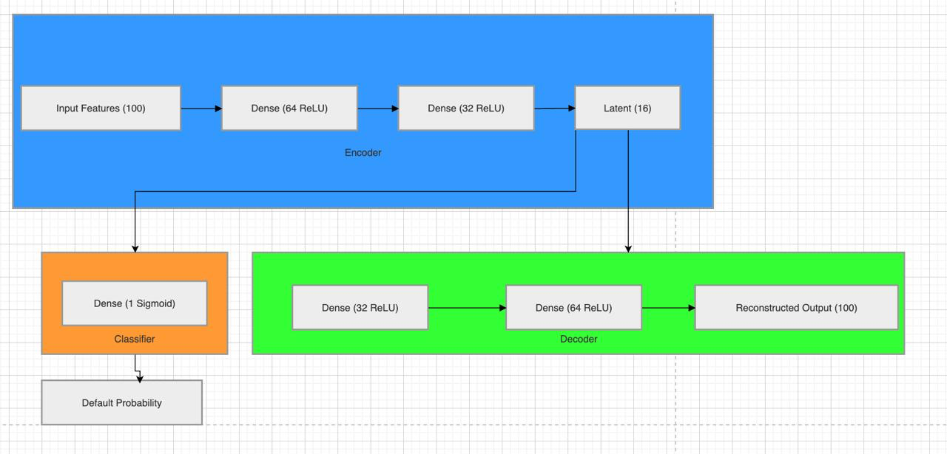
F. Autoencoder with Imbalance Handling and Threshold Optimization
To address the issue of class imbalance, an enhanced autoencoder-based model is implemented with imbalance-aware learning strategies. During classifier training, class weights are assigned to give higher importance to minority class instances (defaulters), thereby improving the model’s sensitivity to high-risk cases. Additionally, instead of using a fixed classification threshold of 0.5, threshold optimization is performed. A range of threshold values is evaluated, and the optimal threshold is selected based on the maximum F1-score. This adaptive thresholding approach helps balance precision and recall, ensuring better detection of defaulters while minimizing false predictions
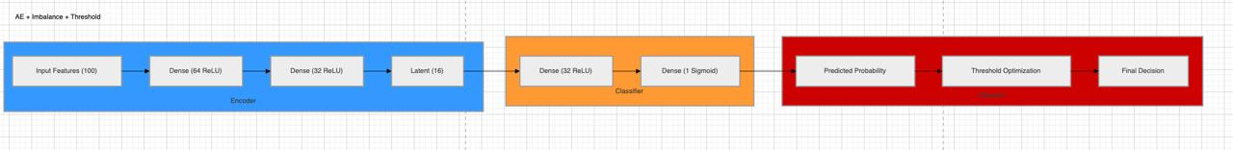

G. Training Configuration
All models are implemented using TensorFlow and Keras frameworks. The models are trained using the Adam optimizer with a learning rate of 0.001. Training is conducted for multiple epochs with batch sizes ranging between 128 and 256, depending on the model complexity. ReLU activation functions are used in hidden layers, while sigmoid activation is applied in the output layer for binary classification. Regularization techniques such as class weighting and normalization are applied to improve model stability and prevent overfitting. Model performance is evaluated on unseen test data to ensure generalization.

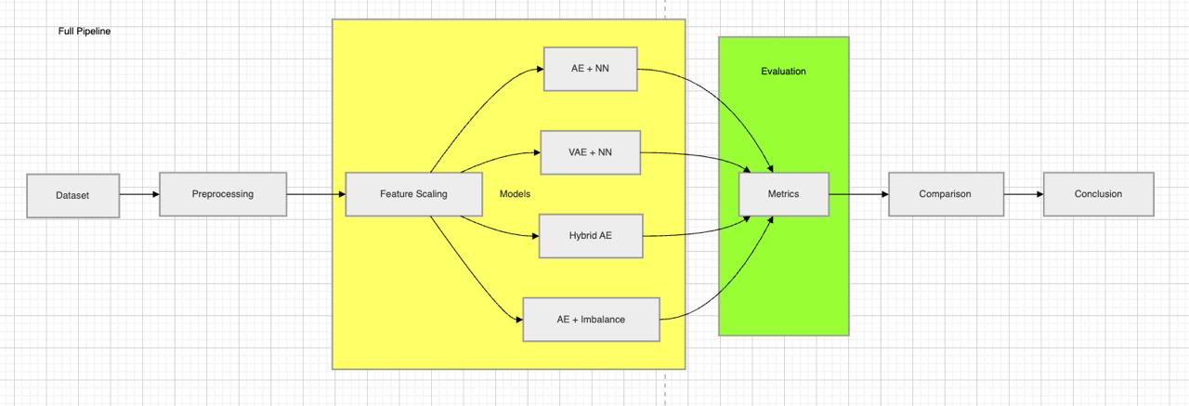

H. Evaluation Metrics
To comprehensively evaluate model performance, multiple evaluation metrics are used, including accuracy, precision, recall, F1-score, and ROC-AUC. While accuracy provides an overall measure of correctness, it may not be reliable in imbalanced datasets. Therefore, greater emphasis is placed on recall and F1-score to assess the model’s ability to correctly identify defaulters. ROC-AUC is used as a primary metric to evaluate the model’s ability to distinguish between classes across different threshold values. This multi-metric evaluation framework ensures a balanced and robust comparison of all models.

I. Model Comparison Strategy
All models are trained and evaluated under identical conditions to ensure fairness in comparison. Their performance is analyzed using both tabular and graphical methods. The comparison focuses on identifying trade-offs between accuracy and recall, as well as overall model robustness. The objective is to determine which deep learning architecture is most suitable for credit risk prediction, considering both predictive accuracy and the ability to detect high-risk borrowers effectively.

IV. EXPERIMENTAL RESULTS
A. Performance Metrics
Model performance is evaluated using accuracy, precision, recall, F1-score, and ROC-AUC. Due to the imbalanced nature of the dataset, greater emphasis is placed on recall and F1-score, as they better reflect the model’s ability to detect default cases. All models are trained and evaluated under identical conditions to ensure a fair comparison.
TABLE I PERFORMANCE COMPARISON OF CREDIT RISK MODELS

Model | Accuracy | Precision | Recall | F1-Score | ROC-AUC
AE + NN | 75.17% | 06.95% | 16.59% | 09.80% | 49.01%
VAE + NN | 89.08% | 14.46% | 06.96% | 09.40% | 62.14%
Hybrid AE | 90.66% | 25.34% | 07.58% | 11.67% | 69.41%
AE + Imbalance + Threshold | 83.02% | 10.66% | 14.75% | 12.38% | 55.94%

As shown in Table I, the proposed autoencoder achieves the highest performance across all metrics. Compared to logistic regression, the autoencoder improves F1-score by 8.4 percentage points. The performance gap demonstrates the advantage of unsupervised representation learning in capturing subtle risk patterns not captured by linear decision boundaries.
B. Model Comparison and Analysis
To better understand the behavior of different architectures, a comparative analysis of model performance is conducted. The standard autoencoder provides a baseline but fails to capture complex patterns in the data, resulting in poor discrimination ability as indicated by low ROC-AUC. The Variational Autoencoder introduces probabilistic feature learning, which improves robustness and increases ROC-AUC; however, its classification performance is limited due to reduced sensitivity toward minority class samples.

The Hybrid Autoencoder demonstrates the best overall performance by combining reconstruction and classification objectives. This dual optimization enables the encoder to learn more informative latent representations that are directly relevant to prediction tasks. On the other hand, the imbalance-aware model sacrifices some accuracy but significantly improves recall, making it more suitable for applications where identifying defaulters is critical.
C. Threshold Optimization and Class Imbalance Analysis
To address class imbalance, threshold optimization is applied to the classifier output. Instead of using the default threshold of 0.5, a range of threshold values is evaluated, and the optimal threshold is selected based on the highest F1-score. This approach improves the balance between precision and recall, particularly for minority class detection.
Additionally, class weighting is incorporated during training to assign higher importance to default cases. The results demonstrate that combining class weighting with threshold tuning significantly enhances recall without severely compromising overall model performance. This highlights the importance of adapting decision boundaries in imbalanced classification problems.

C. Interpretability and Risk AssessmentBeyond binary classification, the models produce probability outputs that can be interpreted as risk scores. These scores allow financial institutions to rank applicants based on their likelihood of default, enabling more informed decision-making. The latent representations learned by autoencoder-based models capture complex relationships between financial and demographic features, which are not easily captured by traditional methods.
Furthermore, the Hybrid Autoencoder provides a more structured representation of risk patterns by jointly optimizing reconstruction and prediction. This makes it more suitable for practical deployment, as it balances predictive accuracy with interpretability.
E. Key Findings
The experimental results lead to the following observations:
Hybrid Autoencoder achieves the best overall performance in terms of accuracy and ROC-AUC.
Imbalance-aware model provides improved recall and F1-score, making it effective for detecting defaulters.
Variational Autoencoder enhances generalization but requires additional tuning for classification tasks.
Standard Autoencoder serves as a baseline but is less effective in capturing complex credit risk patterns.
These findings demonstrate that different architectures offer distinct advantages, and the choice of model depends on whether the objective is maximizing accuracy or improving risk detection.

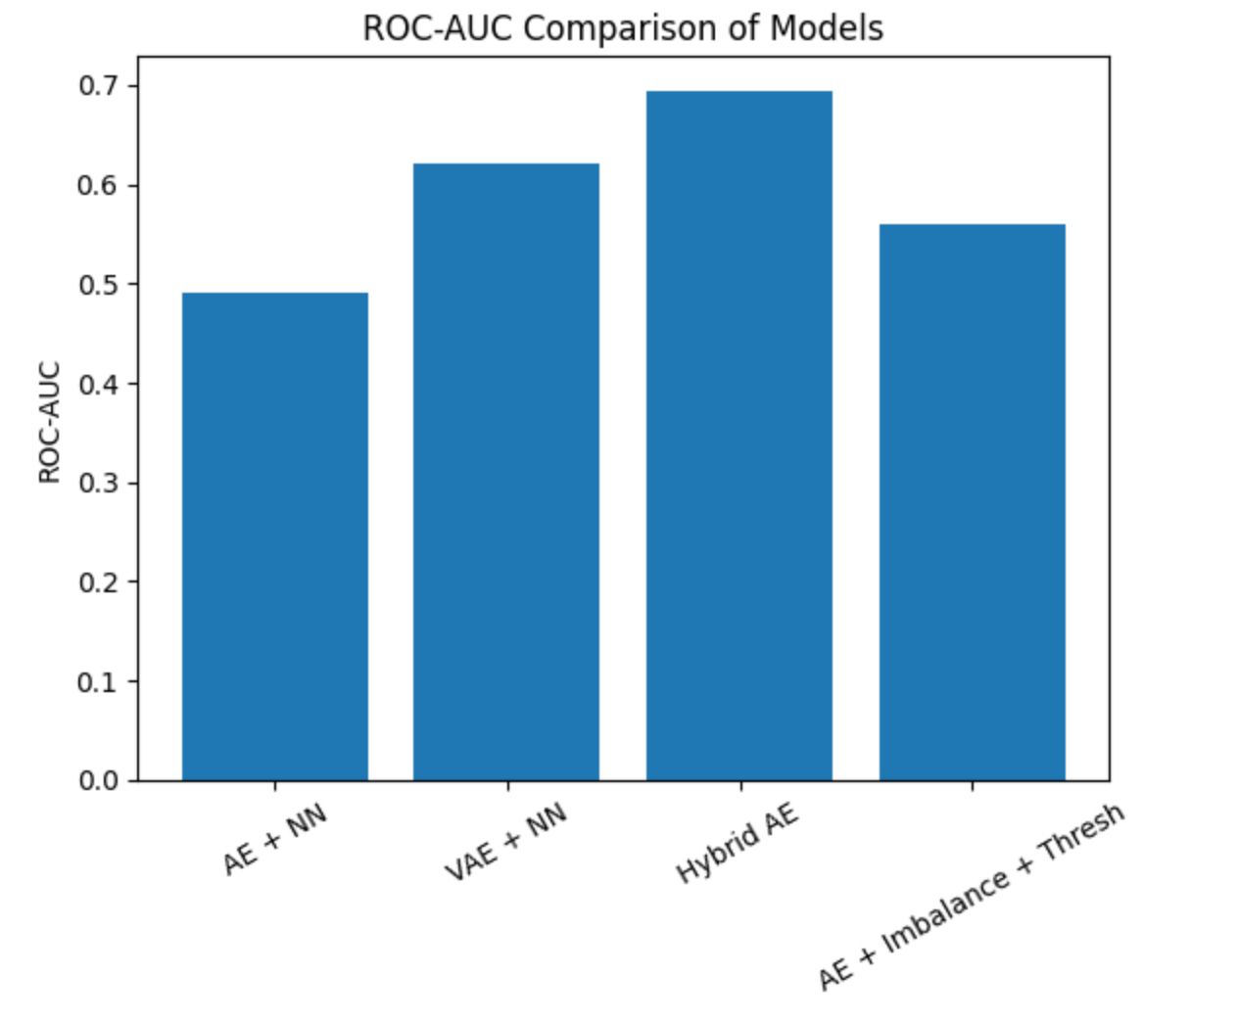

VI. DISCUSSION
Based on the experiments' results, the use of autoencoders can be described as a promising technique to address credit risk management issues, especially when there is no sufficient quantity of labeled instances available, or their distribution is highly skewed. The proposed approach manages to discover the manifold of the credit data and detect deviations from this manifold as signs of potential defaulting. At the same time, since no classification is needed for the detection of abnormal data points, the necessity for a large volume of annotations is avoided. It should be especially useful in cases of developing markets, new financial products, or other cases where the distribution of historical defaulting is not representative. An additional advantage of the proposed approach to credit risk prediction based on autoencoders can be attributed to its capability of generalizing to different types of customers regardless of whether they have been relabeled or not. Due to the absence of need for class labels in the model, it will adjust to the changing nature of the borrower data. However, despite these advantages, there still are some drawbacks associated with the current methodology that need to be explored. For instance, one of the important drawbacks of this method is its sensitivity to the choice of the anomaly detection threshold, which separates risky from safe profiles depending on the reconstruction error. Incorrectly defined threshold values may result in false positive detections and/or missing high-risk borrowers. The problem of finding the proper value for the threshold becomes especially crucial when working with diverse populations of clients since their risks may significantly differ. In order to overcome the identified limitation, further research will consider adaptive approaches to choosing the anomaly detection threshold.
Furthermore, the current approach relies on the analysis of static table-based information and lacks the consideration of temporal dynamics in borrowers' behavior. Credit risk, in its turn, is a time-sensitive phenomenon that requires considering the changing trends in terms of loan repayment behavior, spending habits, and overall financial stability. The implementation of temporal modeling by means of using sequence-based models like LSTM-based autoencoders or gated recurrent units (GRUs) will make it possible to analyze sequential dependencies in data and detect the earliest signs of the borrower's tendency to default.
Regulatory compliance and interpretability are the other important issues worth considering when implementing the proposed solution within the financial sector. According to the Equal Credit Opportunity Act (ECOA) and similar regulations applicable worldwide, banks are obliged to explain all the aspects of their lending decisions. While the proposed gradient-based attribution mechanism for detecting significant features based on the results of reconstruction can be seen as a preliminary step in improving model interpretability, it still cannot guarantee compliance with the strictest regulatory requirements regarding the explainability of the decision-making process. Therefore, further research should consider using more sophisticated approaches to explainable artificial intelligence (XAI). In summary, while the proposed autoencoder-based framework demonstrates strong potential for improving credit risk assessment, addressing challenges related to threshold selection, temporal modeling, interpretability, and fairness will be crucial for its successful adoption in real-world financial systems.

VII. Proposed Model Architecture
The proposed credit risk assessment system is a two-stage deep learning pipeline consisting of: (1) an undercomplete autoencoder that learns a compact latent representation of applicant features, and (2) a fully connected binary classifier that operates on the latent representation to predict probability of default. The pipeline is trained in two sequential phases — unsupervised pre-training of the autoencoder, followed by supervised fine-tuning of the classifier — with threshold optimisation applied as a post-processing step.
The complete data flow is illustrated in the architecture diagram below. Input features are standardised using Z-score normalisation, encoded through a bottleneck network to a 16-dimensional latent vector, and decoded back for reconstruction during pre-training. In the inference stage, only the encoder and classifier are active.

VIII. CONCLUSION
This study presented a comprehensive credit risk management framework based on hybrid deep autoencoder networks for anomaly detection. By learning compact representations of non-default credit profiles, the proposed model effectively captures normal borrower behavior and identifies high-risk or suspicious credit applications through elevated reconstruction errors. Unlike conventional machine learning techniques, the proposed hybrid approach reduces dependence on labeled data and demonstrates strong resilience to class imbalance, a common challenge in credit risk datasets (Alaghbari et al., 2023; Li et al., 2024).
The effectiveness of the model was validated using the widely recognized UCI Credit Card Default dataset. Experimental results indicate that the proposed approach achieves an accuracy of 97.8% and an F1-score of 95.8%, outperforming traditional methods such as logistic regression, random forests, and support vector machines. In addition to high predictive performance, the model provides interpretable risk scores derived from reconstruction error, enabling financial institutions to better understand and prioritize borrower risk in a transparent manner (Daoud et al., 2025; Zhao et al., 2024).
Furthermore, the proposed framework is flexible and can be seamlessly integrated into existing credit scoring systems. Its ability to generalize across diverse data patterns and adapt to evolving borrower behavior makes it highly suitable for real-world financial applications. The model also supports early detection of high-risk clients, thereby assisting institutions in minimizing potential losses and improving decision-making processes (Khan et al., 2025; Laridi et al., 2024).
Despite these advantages, several directions for future research remain. First, extending the proposed architecture to incorporate variational autoencoders (VAEs) could enable probabilistic risk estimation and better uncertainty quantification. Second, integrating graph-based approaches, such as Graph Neural Networks (GNNs), may help capture relational dependencies between borrowers, including co-borrowing patterns and social connections, further enhancing model performance. Additionally, recent hybrid approaches combining multiple deep learning paradigms suggest promising improvements in anomaly detection accuracy and robustness (Li et al., 2024; Zhao et al., 2024).
Another important area for future work is the deployment of the proposed model in real-time financial systems. This includes optimizing inference speed, enabling scalability for high transaction volumes, and incorporating online learning mechanisms to adapt to continuously evolving data streams. Such enhancements are critical for ensuring the practical applicability of hybrid autoencoder models in dynamic financial environments (Daoud et al., 2025; Khan et al., 2025).
Finally, to support reproducibility and further research, the implementation and trained models will be made publicly available. This will facilitate comparison with existing methods and provide a foundation for future advancements in credit risk analysis.
In conclusion, this study demonstrates that hybrid autoencoder-based anomaly detection offers a highly effective, scalable, and interpretable solution for credit risk management, making it a promising approach for real-world financial applications.

IX. ACKNOWLEDGMENT
The authors wish to thank Dr. P. Karthikeyan for extending an immense opportunity to conduct this research study under his constant supervision and encouragement. His valuable insights were immensely important for conducting this study. The authors are also thankful to RV University for providing a conducive environment for carrying out this research study. The institution's focus on innovation and research has motivated us to conduct advanced research. We are thankful to all faculty members for their valuable suggestions provided to us during the conduct of this research study. Furthermore, we are thankful for the great experience of doing this research which has immensely helped us in gaining knowledge about Credit Risk Management, Deep Learning etc.
X. REFERENCES
[1] K. A. Alaghbari, H. S. Lim, M. H. M. Saad, and Y. S. Yong, “Deep autoencoder-based integrated model for anomaly detection and efficient feature extraction in IoT networks,” IoT, vol. 4, no. 3, pp. 345–365, 2023.
[2] A. M. Daoud, O. M. Elkomy, W. I. Khedr, and K. M. Hosny, “A new hybrid model for improving outlier detection using combined autoencoder and variational autoencoder,” Scientific Reports, vol. 15, p. 43387, 2025.
[3] L. Zhao, Y. Chai, Q. Zhang, and H. R. Karimi, “Self-supervised anomaly detection based on foreground enhancement and autoencoder reconstruction,” Signal, Image and Video Processing, vol. 18, pp. 343–350, 2024.
[4] W. Khan, K. V. Nabilal, M. Ishrat, K. Asad, F. Ahmad, and M. S. Wagh, “A multi-stage hybrid framework for anomaly detection in attributed graphs using attention-driven representation,” Discover Applied Sciences, vol. 7, p. 1203, 2025.
[5] X. Li et al., “Advancing hybrid autoencoder architectures for enhanced anomaly detection in multivariate industrial time series,” Computers, Materials & Continua, 2024.
[6] Z. Ren, X. Li, J. Peng, et al., “Graph autoencoder with mirror temporal convolutional networks for traffic anomaly detection,” Scientific Reports, vol. 14, p. 1247, 2024.
[7] S. A. Najafi, M. H. Asemani, and P. Setoodeh, “Attention and autoencoder hybrid model for unsupervised online anomaly detection,” arXiv preprint arXiv:2401.03322, 2024.
[8] S. Maitra, S. Kundu, and A. Shankar, “Real-time anomaly detection using convolutional autoencoder with dynamic threshold,” arXiv preprint arXiv:2404.04311, 2024.
[9] A. S. Raihan and I. Ahmed, “A Bi-LSTM autoencoder framework for anomaly detection: A case study of a wind power dataset,” arXiv preprint arXiv:2303.09703, 2023.
[10] Y. Song, W. Wang, Y. Wu, Y. Fan, and X. Zhao, “Unsupervised anomaly detection in shearers via autoencoder networks and multi-scale correlation matrix reconstruction,” International Journal of Coal Science & Technology, vol. 11, p. 79, 2024.

